MIS 6326 - DATABASE MANAGEMENT

Jobster Database

**Created By**

Ashwin Kannan(axk162031)

Christy Thomas(cxt163130)

Divya Jayaprakash(dxj160830)

Gautami Murugan(gxm161330)

Vijay Shankar Balaji(vxb161031)

**Expert Guidance**

**Dr. Young Ryu**

**Project Report Contents**

1] Jobster Company Background

2] Database Scope and Table Description

3] Entity-Relationship Diagram

4] Relational Database Schema - Relational Data Model

5] Data Input Screen Forms

6] Reports

7] Menus

Jobster Company Background

Jobster is a widely used web application for job listings. It is a portal where employers can post a job, users can apply for a job and can review their jobs. Jobster is currently used over 60 countries. It is one of the most trafficked employment websites in the [United States](https://en.wikipedia.org/wiki/United_States).

The site aggregates job listings from thousands of websites, including job boards, staffing firms, associations, and company career pages. Jobster began allowing job seekers to apply directly to jobs on the website directly and is now offering resume posting and storage. Jobster is based in [Dallas, TX](https://en.wikipedia.org/wiki/Austin,_TX).

There is a variety of information about companies, jobs, interviews etc.

***Company Review*** *-*This section details the company’s overall rating, pros, cons, etc.

***Job Vacancies*** - Lists the job postings and the number of vacancies

***Interview Questions*** - The most difficult or unexpected questions asked during an interview and insights on the candidate's responses.

***Interview Ratings*** - This section rates whether the interview was easy or difficult, positive or negative.

***Interview Process*** - Details the length of the candidate's interview process from start to finish (days, weeks, months) and what was included as part of the interview process: (i.e. phone interviews, 1x1 or panel interviews, skills tests, background checks, etc.)

***Compensation and Benefits*** - Details on whether the candidate was able to negotiate the offer, and if so, what advice would they offer to others in the same situation.

***Problem Statement:*** The more information someone has, the better equipped someone will be to ace an interview or choose their dream company. There is a need for information to understand whether the company is up to their expectation. With the expansion of the job market, there is a need to for a system which will be adequate for the job listings and also to accommodate future expansion. Jobster needs a relational database to keep track of all the information it has.

Database Scope and Table Description

1. **User Table**

This table contains all the information related to the users who are job seekers and reviewers. Users are central to the business and are the focus of transactions in the database. Each user has a unique identification number, i.e. User Id and has other attributes such as First Name, Last Name, Email ID, Date of birth, Gender, Experience and Education.

1. **Company Table**

This table contains the details about the companies which are registered in the Jobster and contains the job postings and has a unique identifier, the primary key, i.e Company Id and has other attributes such as Company Name, Company Website Url, Type of the company, City where it is located and the state.

1. **Job Table**

This table contains the job postings made by the employers and has the description and different posting of jobs across various fields and technologies. This table has Job_Id as primary key and has various other attributes such as Job description, title , city and state of job posted and has foreign key of employee id and also lists job vacancy.

1. **Interview Review Table**

This table contains the interview reviews posted by the user, the difficulty level, experience of the candidate and questions which were asked during the interview, the company where the interview happened.

Attributes in this table are Difficulty Level, Overall Experience, Questions, Interview Date, Result of the Interview and the foreign keys are User Id, Company ID and Job Id.

1. **Employer Table**

This table contains the job posted by the employers for the companies and the name of the employee manager who posted and has the primary key i.e Emp ID and the attributes such as First Name, Last Name, Email ID and Company ID.

1. **Company Review Table**

This table contains the review given by the user about the company and the various attributes such as Employee Status, Pros and Cons of the job, Advice to the management, Review about the title and has the User ID and Company ID as the foreign key.

1. **Salary Review Table**

This table consists of the review of the salary of the job for that company given by the user and it records various attributes in the salary like base pay, incentives and has the foreign keys User id, Company id and Job ID

1. **Benefits Review Table**

This table contains the benefits of the job and the benefits provided by the company for a particular job like the Work from Home option, discounts, Health Insurance and other aspects where the foreign key of this table are User Id, Company Id and Job Id.

1. **Application Table**

Since the user can apply for the job directly through the website, the application table here records the application of the user for the job where Application ID is the primary key and the attributes such as Status, User ID and Job Id.

Entity-Relationship Diagram (MS Visio)

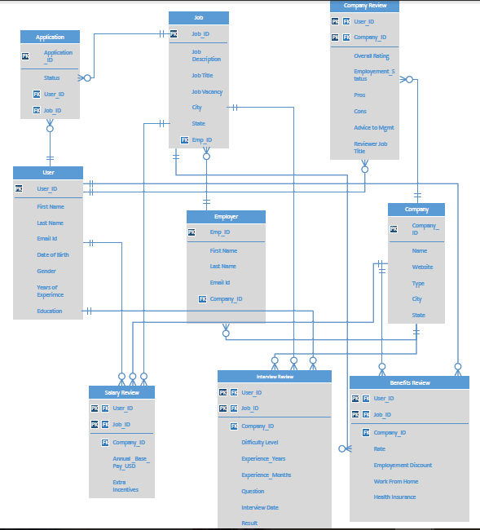

Relational Database Schema

User (User_ID, FirstName, LastName, Email, DateofBirth, Gender, YearsOfExperience, Education)

User.FirstName Not Null

User.LastName Not Null

Company (Company_ID, Name, Website, Type, City, State)

Company. Company_Name Not Null

Job(Job_ID, JobDescription, JobTitle, City, State, JobVacancy, Emp_ID)

Job.Title Not Null

Job.JobVacancy Not Null

Job.Emp_ID Not Null

CONSTRAINT FOREIGN KEY FK (Emp_Id) REFERENCES (EMPLOYER.Emp_Id)

Interview(DifficultyLevel, Experience_Years, Experience_Months, Question, InterviewDate, Result,

User_ID, Company_ID, Job_ID)

Interview.Company_ID Not Null

CONSTRAINT FOREIGN KEY FK2 (User_Id) REFERENCES (User)

CONSTRAINT FOREIGN KEY FK3 (Company_Id) REFERENCES (Company)

CONSTRAINT FOREIGN KEY FK4 (Job_Id) REFERENCES (Job))

Employer(Emp_ID, FirstName, LastName, EmailID, Company_ID)

Employer.FirstName Not Null

Employer.LastName Not Null

Employer.Company_ID Not Null

CONSTRAINT FOREIGN KEY FK5 (Company_Id) REFERENCES (Company))

CompanyReview(Overall Rating ,Employment_Status, Pros, Cons, AdviceToManagement, ReviewerJobTitle, User_Id, Company_ID)

CompanyReview .OverallRating Not Null

CompanyReview .User_ID Not Null

CompanyReview .Company _ID Not Null

CONSTRAINT FOREIGN KEY FK6 (Company_Id) REFERENCES (Company)

CONSTRAINT FOREIGN KEY FK7 (User_Id) REFERENCES (User))

Salary Review(Annual_Base_Pay_USD, Extra_Incentives, User_ID, Company_ID, Job_ID)

SalaryReview.Company_ID Not Null

CONSTRAINT FOREIGN KEY (Company_Id) REFERENCES (Company)

CONSTRAINT FOREIGN KEY (User_Id) REFERENCES (User)

CONSTRAINT FOREIGN KEY (Job_Id) REFERENCES (Job))

BenefitsReview(Rate, Employment Discount, WorkFromHome, HealthInsurance, User_ID, Company_ID, Job_ID)

BenefitsReview.Company_ID Not Null

CONSTRAINT FOREIGN KEY (Company_Id) REFERENCES (Company)

CONSTRAINT FOREIGN KEY (User_Id) REFERENCES (User)

CONSTRAINT FOREIGN KEY (Job_Id) REFERENCES (Job))

Application(Application_ID, Status, User_ID, Jobs_ID)

Application.User_ID Not Null

Application.Jobs_ID Not Null

CONSTRAINT FOREIGN KEY (Job_Id) REFERENCES (Job)

CONSTRAINT FOREIGN KEY (User_Id) REFERENCES (User)

Data Input Screen Forms

1. **User Sign Up:**



1. **Login:**



1. **Job Posting:**

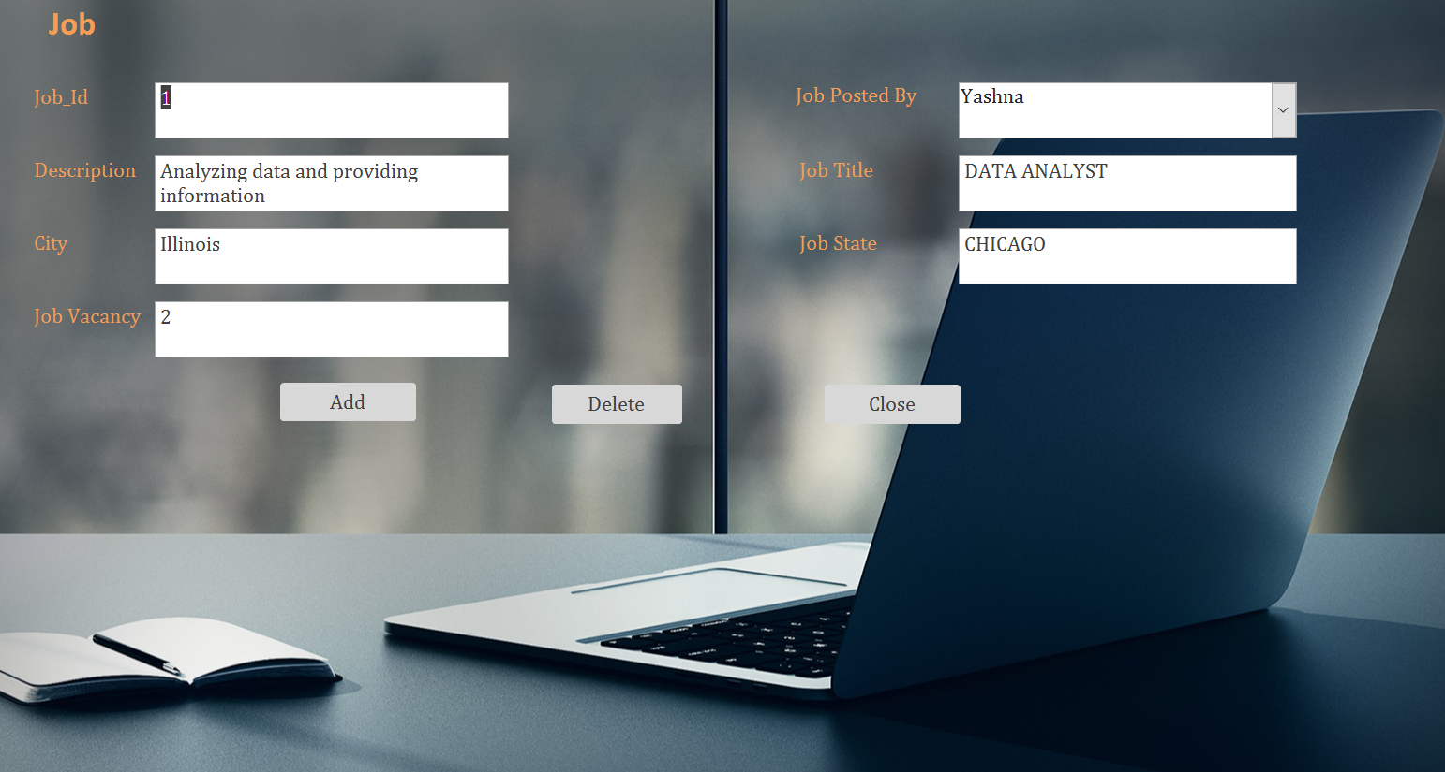

1. **Apply for a Job:**

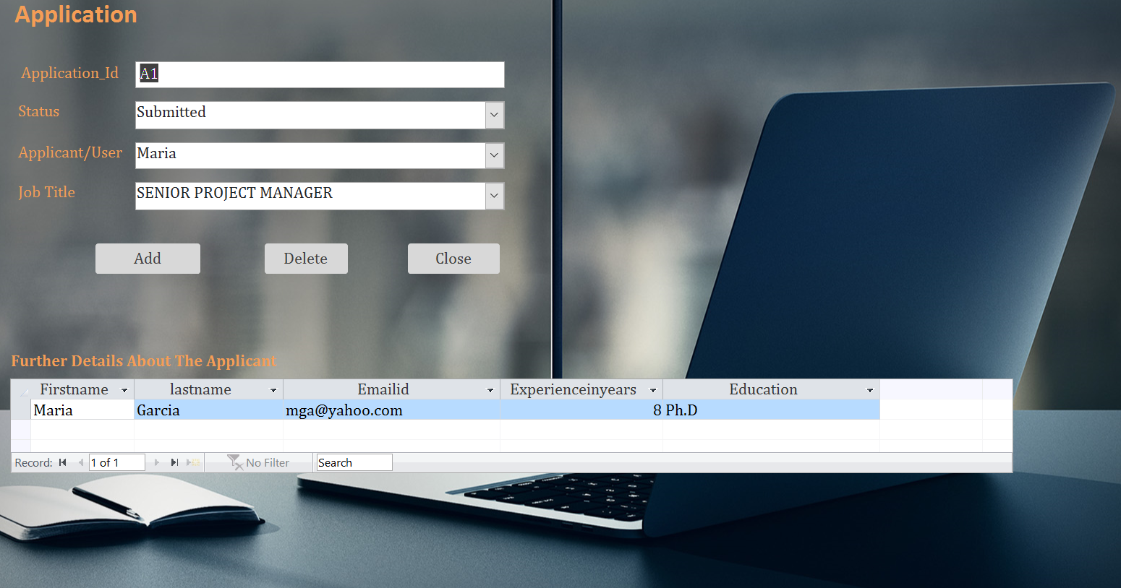

1. **Reviews:**
2. **Company Review**

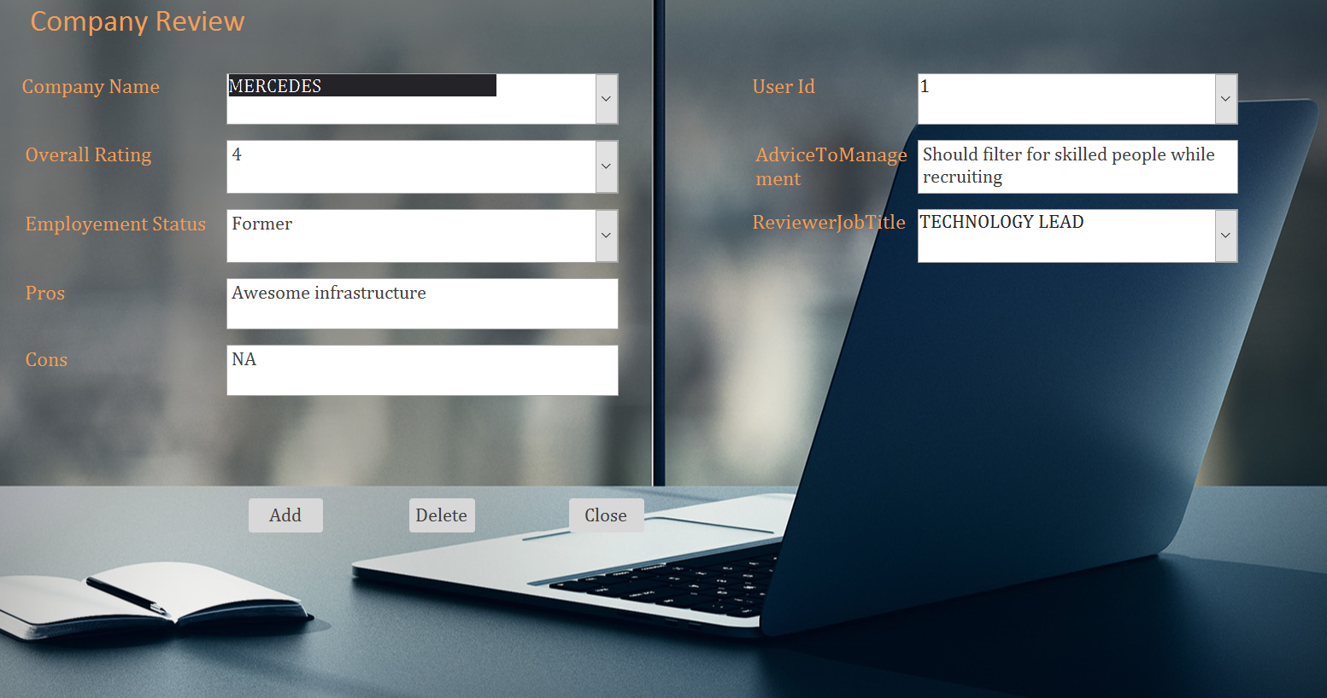

1. **Benefits Review**

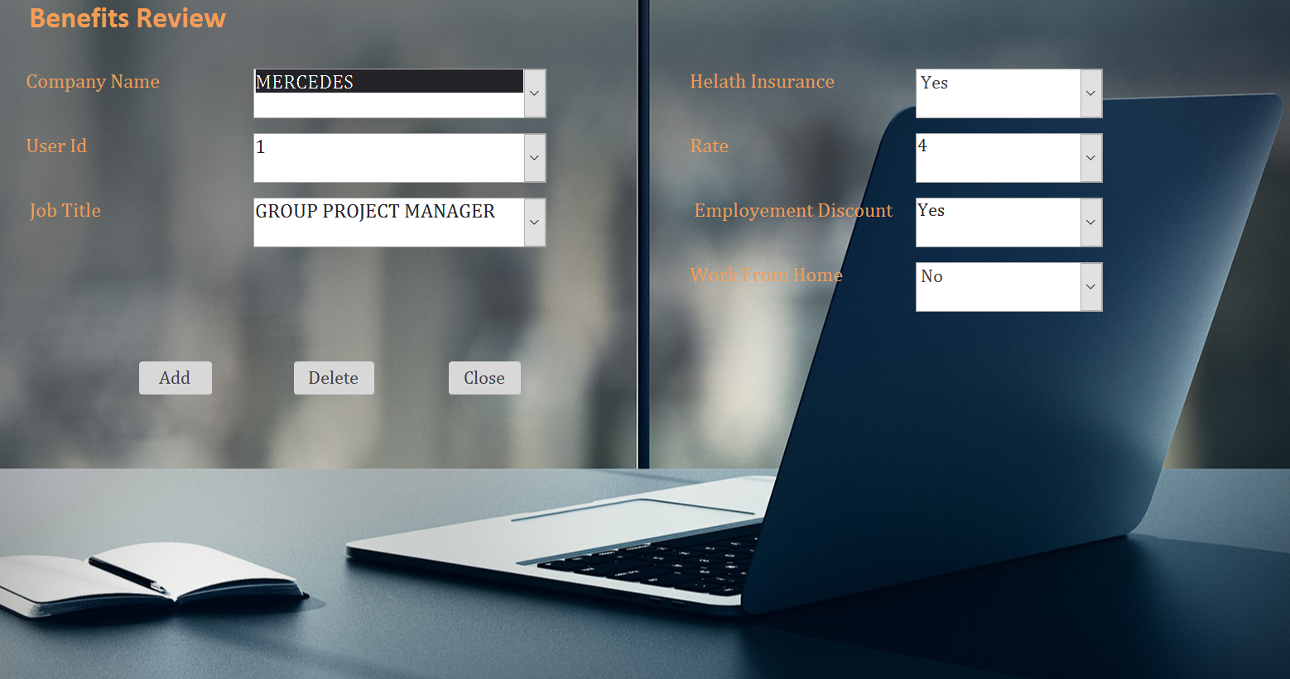

1. **Salary Review**

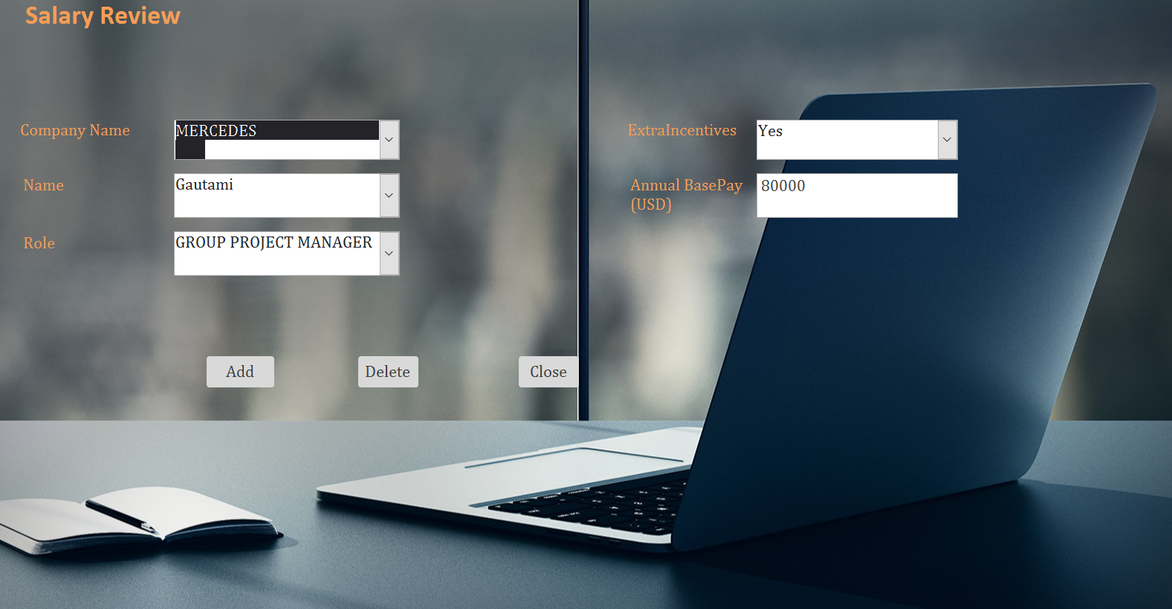

1. **Interview Review**

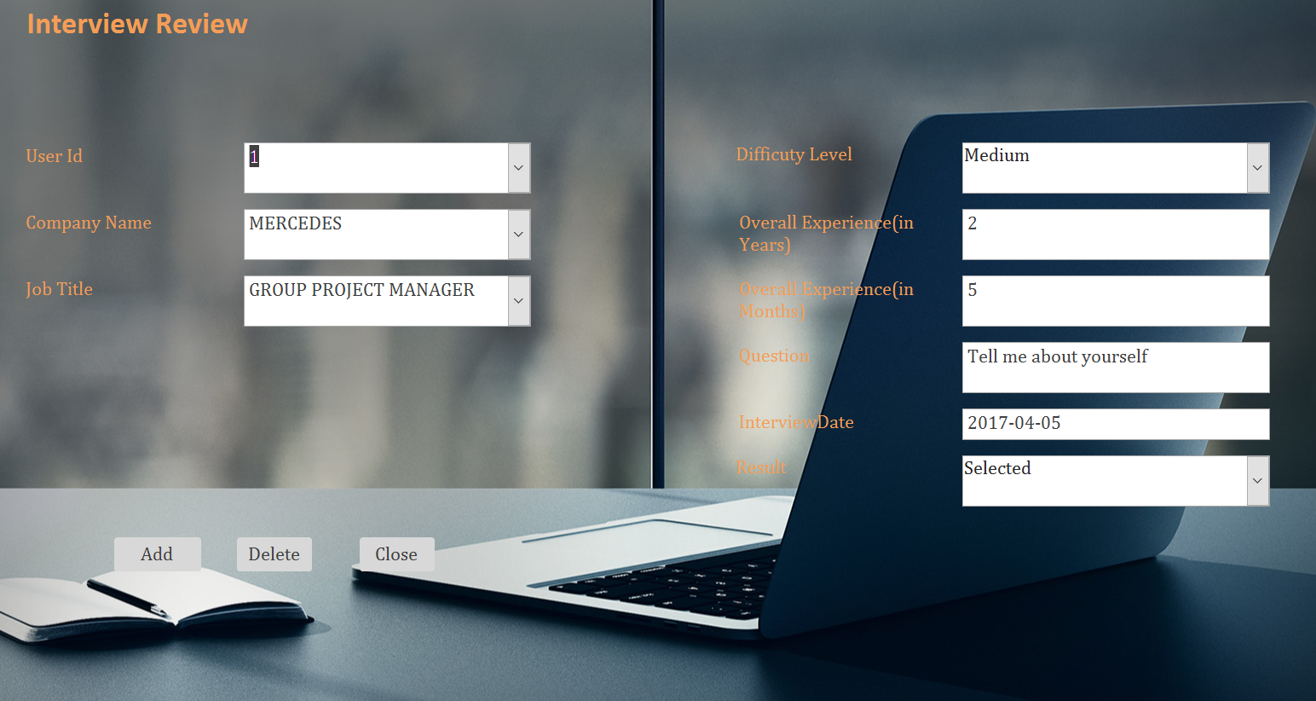

1. **Company Details:**

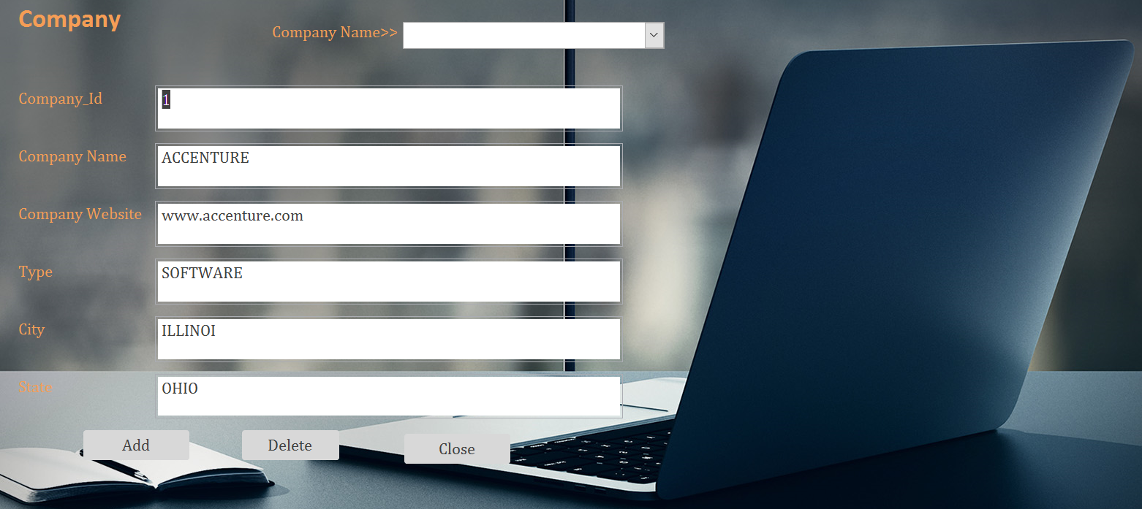

1. **Employer Details:**

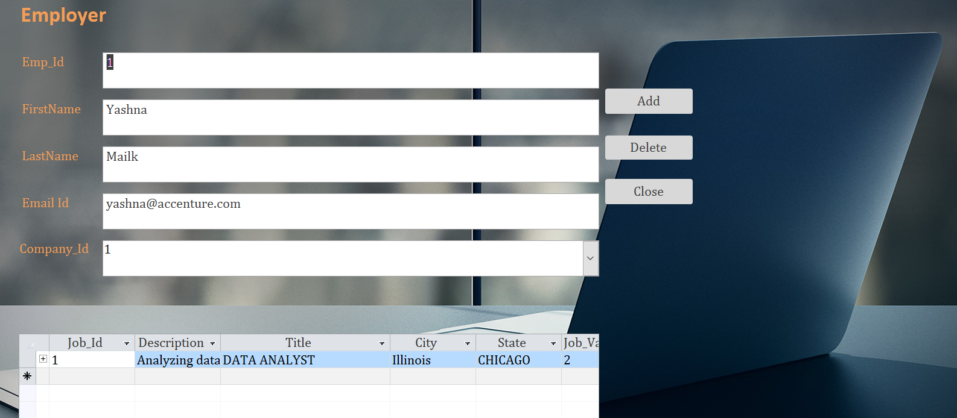

Reports

1. **Job Vacancies**

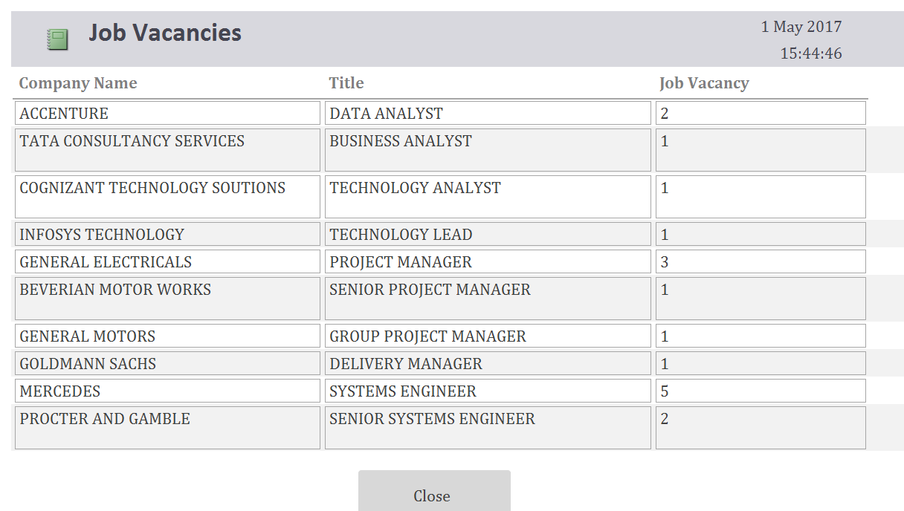

1. **Salary Trends**

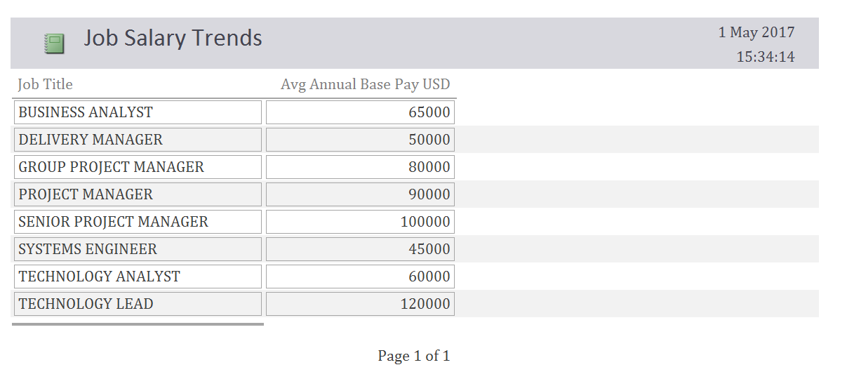

1. **Benefits Satisfaction Index**

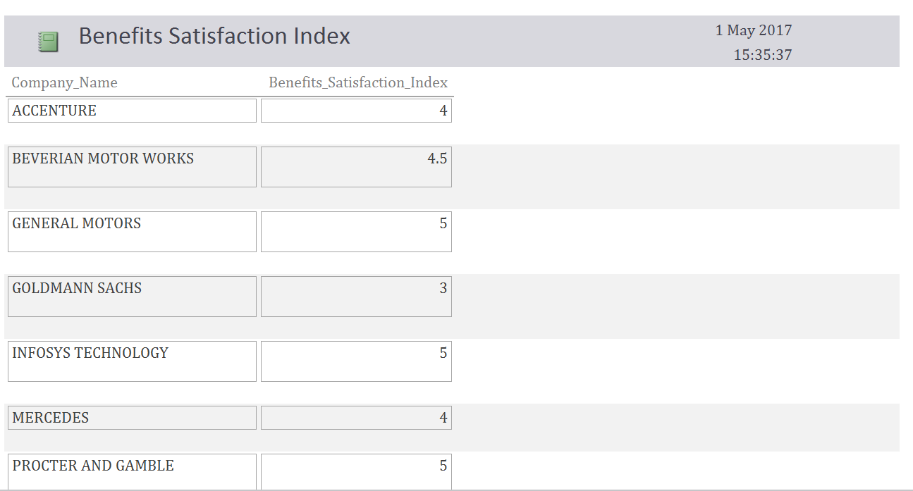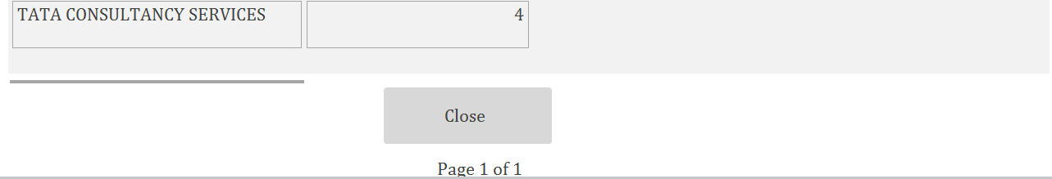

1. **Employee Benefits**

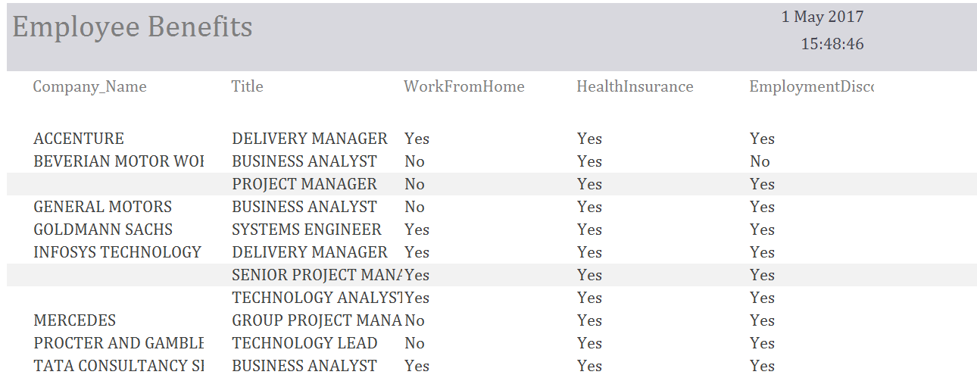

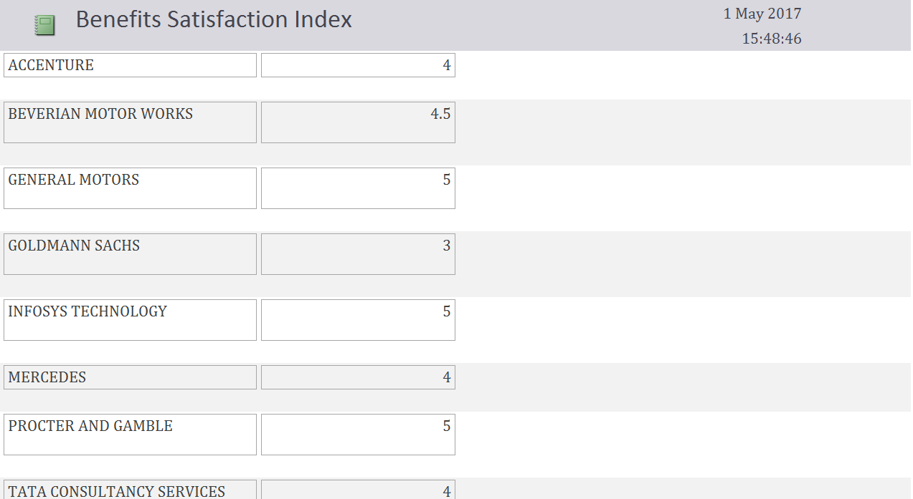

1. **Company Review Summary**

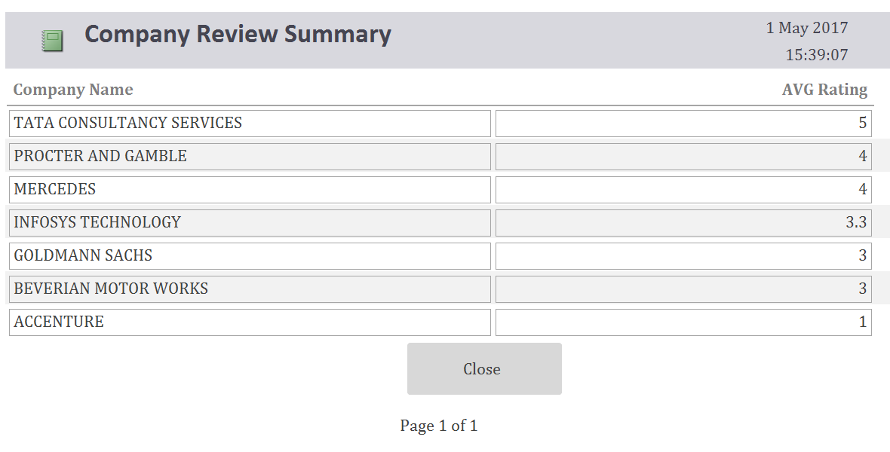

1. **Interview Details**

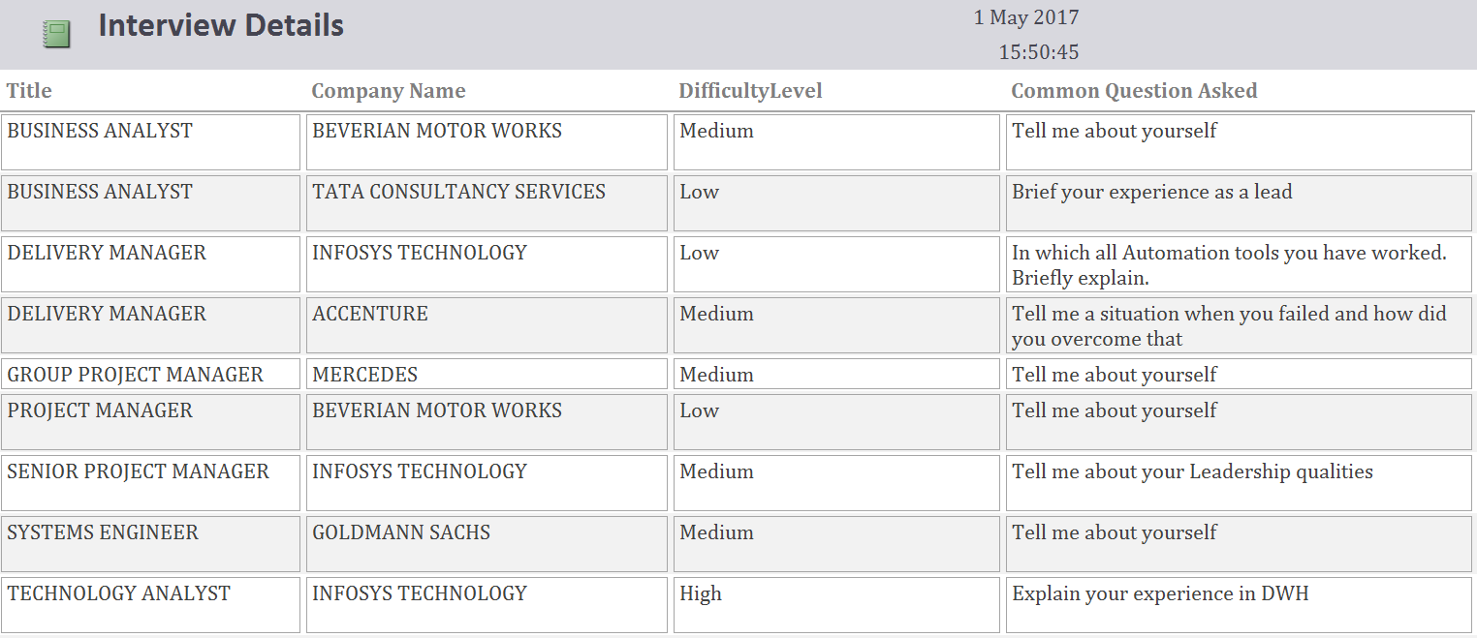

Menus

1. **Jobster Menu**



1. **Login Menu**



1. **Reviews Menu**



1. **Executive Summary Reports Menu**

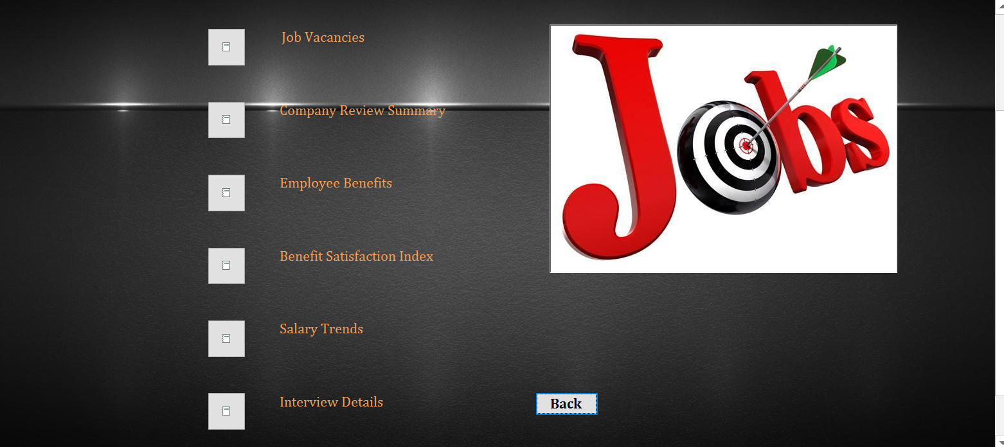

Contributions:

Ashwin Kannan: Wrote the project description and Data Entry

Christy Thomas: Created Forms and Reports

Divya Jayaprakash: Created Menus, forms and Reports

Gautami Murugan: Created the ERD and Forms

Vijay Shankar Balaji: Created Tables and formulated the final draft

Conclusion:

To put it in a nut shell, the Jobster database is up and running. The forms and reports are active and usable. There is a proper navigation through the menus.